Project Design Phase-II
Data Flow Diagram & User Stories

Date | 31 January 2025
Team ID | SWTID-2026-9658
Project Name | Customer registry
Maximum Marks | 4 Marks

Data Flow Diagrams:
A Data Flow Diagram (DFD) is a traditional visual representation of the information flows within a system. A neat and clear DFD can depict the right amount of the system requirement graphically. It shows how data enters and leaves the system, what changes the information, and where data is stored.
DFD Level 0 (Industry Standard)
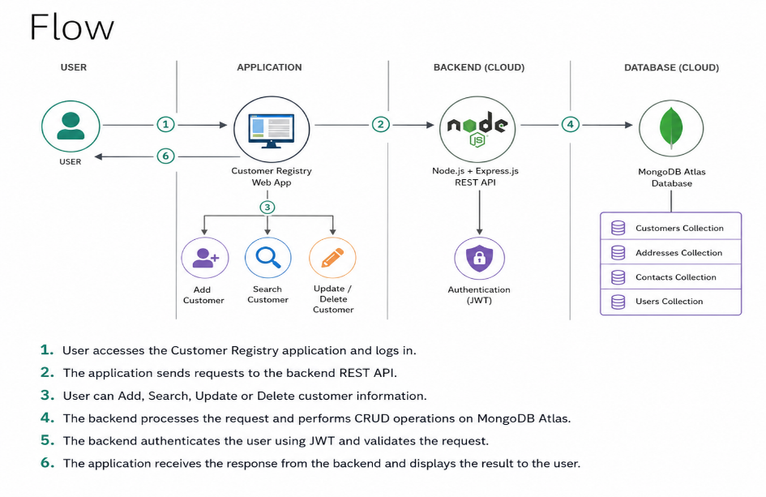
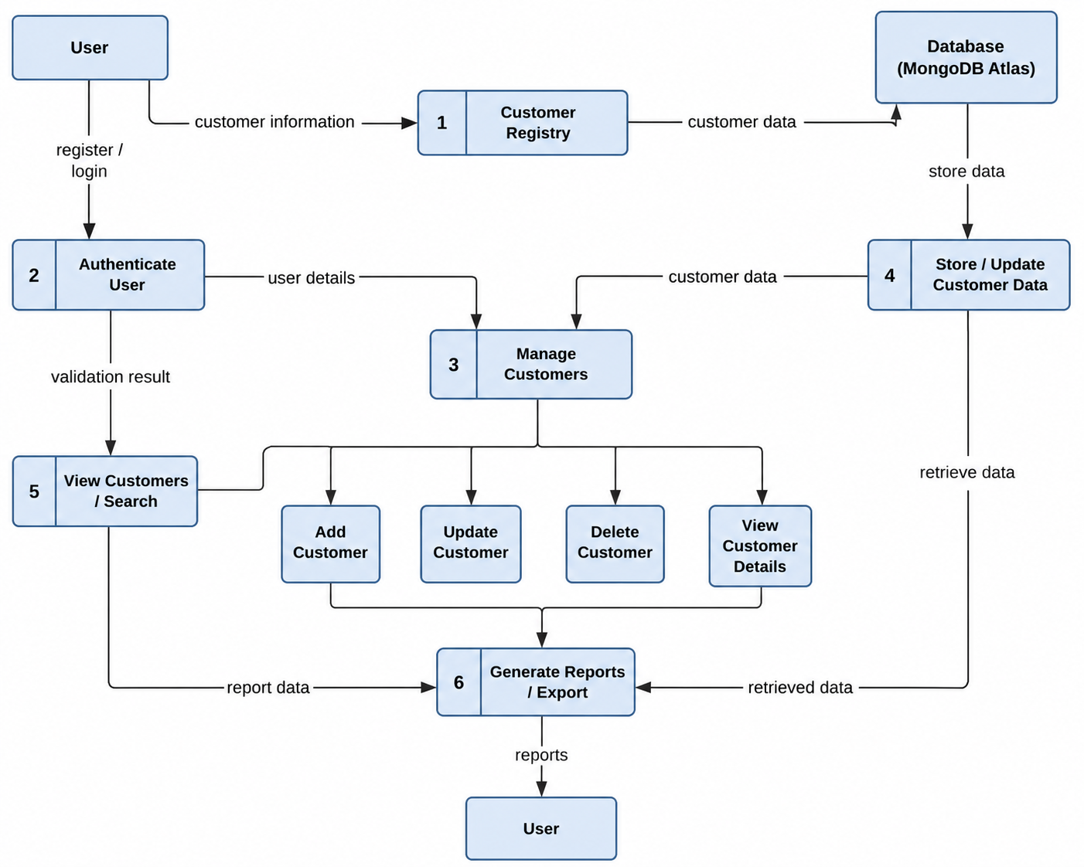

User Stories

User Type | Functional Requirement (Epic) | User Story Number | User Story / Task | Acceptance criteria | Priority | Release
Customer (Mobile user) | Registration | USN-1 | As a user, I can register for the application by entering my email, password, and confirming my password. | I can access my account / dashboard | High | Sprint-1
Customer (Web user) | Dashboard View | USN-2 | As a user, I want to filter my past logs to monitor real-time processing milestones so that I know my ticket isn't lost. | Filtering runs instantly on the reactive client interface without reloading the whole web page. | Medium | Sprint-2
Support Agent | Status Overrides | USN-3 | As an agent, I can modify the ticket status to 'In Progress' or 'Resolved' and attach resolution details. | Status updates instantly alter the customer's dashboard tracking milestone status. | High | Sprint-1
Support Agent | Ticket Fulfillment | USN-4 | As an agent, I can view an organized queue of all open tickets sorted by submission timeline order | Queue renders all vital tracking fields clearly across a standard workspace screen layout. | High | Sprint-1
Customer Care Executive | Ticket Management | USN-5 | As an executive, I can view a centralized queue of all incoming complaints assigned to my department | The interface provides a clear list view of open tickets sorted by submission timestamp. | High | Sprint-1
Customer Care Executive | Ticket Processing | USN-6 | As an executive, I can update a ticket's status from 'Pending' to 'In Progress' or 'Resolved' and add text updates. | Status updates modify the MongoDB database record and immediately reflect on the user's dashboard. | High | Sprint-1
Administrator | Access Controls | USN-7 | As an administrator, I can change authorization roles to promote regular users into formal Support Agent staff roles. | Access changes modify database document roles securely and dynamically enforce backend routing permissions. | Low | Sprint-2

